PROJECT PROPOSAL FOR 100 PROJECTS FOR PEACE

Teaching Tolerance through Computer Education
in Port-au-Prince, Haiti
Valcourt Honoré
Kayla Nachtsheim
Parul Sohal

Lewis & Clark College
June-August, 2015
Table of Contents

Proposal page 3-4

Budget page 5

Appendix: Fundraising Plan page 6-7

Appendix: Who We Are page 8

Appendix: Letters of Support page 9-17

Appendix: Curriculum Information page 18-21

Appendix: Measurement and Evaluation Information page 22

Appendix: Computer Technology Center Specifics page 23

Appendix: Additional Support from our Contacts page 24-25

Teaching Tolerance through Computer Education
Valcourt Honoré, Kayla Nachtsheim, and Parul Sohal
Introduction
As a teenager growing up in the Carrefour-feuilles neighborhood of Port-au-Prince, Haiti, Valcourt Honoré studied at Lycée Jean Jacques public school. Like most Haitian public schools, Lycée Jean Jacques struggled with overcrowded classrooms, overworked teachers, and little access to resources such as school libraries, computers, and enrichment programs. However, Valcourt felt fortunate to be at Lycée Jean Jacques in a country where only 50% of children under 18 attend school.
Despite excelling academically, Valcourt couldn’t help but notice that the private school kids he encountered behaved with an air of superiority. They avoided him at church and withheld invitations to social gatherings. Riding public transit with these students was humiliating. Public school students were sneered at and told “you won’t amount to anything.” The intense taunting and social isolation left Valcourt feeling resentful and upset.
Eight years later, after graduating from high school and attending college in the U.S., Valcourt still feels a strong sense of injustice from his experience which led him to reach out to classmates Parul and Kayla. Private school students throughout Haiti continue to look down on public schoolers who they hardly know. As a result, public school students from families with less financial means resent private school kids with whom they barely interact.
With over half of Haiti’s population made up of youth under 25 years old, the persistent lack of tolerance between young people is fueling dangerous political clashes and class conflicts that permeate Haitian society. In recent years, thousands of young Haitians have been drawn into the violence of political opposition groups, burning tires and defacing storefronts in the streets. Cooperation and peaceful negotiation are not yet seen as viable methods to achieving social and political reform. As a team, we want to build a more peaceful alternative for Haitian youth to value each other regardless of their backgrounds.
Our Project
We define peace in this community as acceptance and unity across differences. Our project will promote peace by creating an atmosphere where students share their personal stories, creativity, and understanding with one another, while letting go of past assumptions of their peers. Computer education will serve as a medium for building peace as we work with young Haitians from all backgrounds to engage in group learning through dialogue. Haiti, as in many developing countries, computer skills are now a critically important factor in finding work. Even basic computer training is in high demand and short supply. As computers and internet access act as a platform for sharing ideas and perspectives, our project will combine the practical need for computer skills with a curriculum that will teach tolerance through activities that encourage active listening of other students’ perspectives, consensus-based decision-making, and constructive peer evaluation.
Our curriculum will promote peace by facilitating active listening between students. For our two classes of ages 11-14 and 15-20, we will pair each student with someone outside their social circle, whether from public schools, private schools, or not in school. Working in pairs, two students per computer, students will find common ground while learning technical skills and participating in exercises to promote communication, cooperation, and tolerance. We plan to have daily 5 minute ‘warm up’ sessions for student pairs to discuss the topic related to that day’s activities (such as respect, nonverbal communication, inclusion, etc.).
Consensus-based decision-making is an important aspect of peacebuilding that allows people to work together despite their different views. In the classroom, we will demonstrate consensus-based decision-making by frequently gathering feedback from all teachers and students to refine the curriculum. Students will work in groups of 4 (2 pairs) on a computer-based final project centered on Haitian history or contemporary affairs inspired by the class field trip to the National Museum. We will guide groups to collectively decide upon a topic, theme, research methods, and design of their presentation, ensuring equal participation from all students. At the end of the program, students will share their final projects with the community for a celebration of their accomplishments.
Throughout the class students will have opportunities to discuss the work they’ve completed and give constructive peer evaluation. We will emphasize the importance of constructive criticism of the work completed and not of the individual. They will learn to accept and appreciate their peers’ perspectives and share their own in a respectful way. Leveling the playing field among our students will contribute to lasting peace.
Please see our curriculum detailed in the appendix for more information about how we will approach these three areas in our classes.
Practicality
We are working with Le Village des Petits Princes School, which has operated a popular and respected summer program for over 20 years. Each summer approximately 200 students take a variety of academic classes and manual skills training. Located in the Carrefour-feuilles neighborhood where Valcourt grew up, the summer program draws youth from a 35km radius in Port-au-Prince. The existing summer program at Le Village des Petits Princes School charges program fees, which restrict participation to those with the ability to pay. Fortunately we have negotiated with the school administration to offer our six-week summer computer education program at no charge for up to 50 students. The administration will help us select a diverse group of students from different areas, economic statuses, genders, and schooling backgrounds.
The director and staff of Le Village des Petits Princes School are very supportive of the project. They share our vision of teaching tolerance and overcoming stereotypes. As the program’s director Pastor Pierre Marcel Milord says “the best method to promote peace in the long-term is to encourage dialogue, stronger interactions and cooperation among today’s younger generation.” Our agreement is that in addition to creating the summer class, the computer center will be available to the entire community during the school year and will be staffed by a teacher that we will train.
As a team of diverse strengths and experiences, each of us will offer something valuable to this project. Valcourt brings Economics and Foreign Languages skills along with personal experience and contacts that will be invaluable in developing relationships and partnerships. Parul brings computer science skills and a curriculum development background. Kayla brings expertise with International Development, project management, conflict mediation, and the French language. With our combined teaching experience in India, Haiti, Costa Rica, and the U.S. we will create a summer computer education program that will be self-sustaining and peace promoting.
Measurement and Evaluation
We will measure the success of our efforts by distributing an evaluation at the start, midway, and end of the program for students and teachers. The student evaluation will gauge what students learned about themselves and each other. We will also assign the four summer program teachers to observe a few of the small groups in each class to make sure that all students in the group are comfortable participating. The teacher evaluation will help us understand their assigned group’s dynamics and improve our curriculum.
Proposed Schedule
Weeks | Teaching Hours | Content(younger group 30 students ages 11-14) | Teaching Hours | Content(older group 20 students ages 15-20)
Jun 26- Jul 3 | 5 | 3 days materials set up, 4 days teacher training | (same) | 3 days materials set up, 4 days teacher training
Jul 6-11 | 5 | Teacher training | (same) | Teacher training
Jul 13-18 | 3 | (Classes start) Welcome!: Introduction to Windows, Paint, Microsoft Word | 2 | (Classes start) Welcome!: Introduction to Windows, Paint, Microsoft Word, Powerpoint
Jul 20- 25 | 3 | Research and Share!: Introduction to internet research & Powerpoint | 2 | Contemporary Affairs, Android applications, and Prezi
Jul 27- Aug 1 | 3 | Cheep, growl, scratch: All about animals & fun with the Scratch program | 2 | Best practices for internet research and Curriculum Vitae (C.V.) writing
Aug 3- Aug 8 | 3(plus field trip) | Final Group Project preparation: Make a website!  (Field trip to National Museum) | 2(plus field trip) | Final Group Project preparation: Make a website!  (Field trip to National Museum)
Aug 10-15 | 3 | Final Group Project Continued: Social Media & Diverse Truths | 2 | Final Group Project preparation: Make a website!
Aug 17-22 | 3 | Final Group Project last preparations: Present and evaluate each other  (Final community celebration) | 2 | Final Group Project last preparations: Present and evaluate each other  (Final community celebration)
Sustainability
Our goal for this project is to create an ongoing opportunity for Haitian youth to work across differences through computer education. We are excited to provide a staffed, free computer center for the community thanks to our partnership with Le Village des Petits Princes school. This program will continue to promote peace for many more students from the surrounding neighborhoods in the years to come. Our hope is that this curriculum will serve as a model for other schools and similar programs in Haiti.
Key aspects of sustainability woven into our project include:
- Teacher training: We will provide curriculum training and support for the four summer program teachers at the start of the program. We will spend the first 11 days teaching them the curriculum, building trust, and making adjustments based on their input. These teachers will be observing, learning, and ultimately empowered to take over teaching the class in subsequent years. In the classroom we will take turns holding class with the summer teachers and give feedback on their performance.
- Community resource: Pastor Milord and Le Village des Petits Princes’ staff are thrilled at the prospect of providing a community computer center that will serve people of all backgrounds and create a powerful sense of unity and equality. This will ultimately create peace across the community. They have agreed to pay a permanent staff member who we will train, and who will maintain the computer center throughout the school year. Any community member can get a free membership card to use the computer facilities.
- Student involvement: As part of the curriculum students will create information sheets in French and Creole for each topic covered in the summer program. For instance, one group will write up a sheet about how to use Microsoft Powerpoint, while another group will create one for HTML. These information sheets will become a valuable learning tool for community members to reference. Summer program graduates will also be encouraged to volunteer at the center to share their skills and give back to the community.
- Continued guidance: Upon completion of the project we plan to transfer ownership of the summer program and center to Le Village des Petits Princes school. We will keep in contact with our connections there to check in about the progress of the summer program. The center will use the membership cards to record the personal information of young people who visit the center. In a year’s time we will evaluate the distribution of members enrolled in public schools, private schools, or not in school. In addition, Valcourt expects to visit the school every summer in order to support the instructors and students with any challenges they might face.
Post-program sharing
Upon returning to campus, we will share our peace project and experiences in Haiti with the greater Lewis & Clark community through an on-campus presentation and discussion in September 2015. We will showcase our work, our grant writing process, and our challenges. We will also reach out to the following groups to give presentations that are relevant to those groups’ specific interests: Computer Science Classes, Latin American Studies classes, Hispanic Studies classes, the undergraduate Education class, Lewis & Clark College Graduate School of Education, buildOn club, French club, Pluralism and Unity Board, and Lewis & Clark Office of Student Leadership and Service. In addition, we will host a grant writing workshop for students in October 2015. We hope to encourage other students to apply for 100 Projects for Peace through these presentations and workshops.
Teaching Tolerance through Computer Education: Project Budget
Items | Estimated Amount | Subtotal by Category | Price Source | Funding source | Purchase (Haiti/U.S.)
Equipment Expenses
20 laptops($300/unit) | $6,000 | Subtotal: $8,210 | Interconnection.org | Davis Funding | U.S.
20 computer lockers( $15/unit) | $300 | Subtotal: $8,210 | CompHaiti company | Davis Funding | Haiti
1 combined printer/scanner | $80 | Subtotal: $8,210 | CompHaiti company | Davis Funding | Haiti
1 LCD projector | $450 | Subtotal: $8,210 | CompHaiti company | Davis Funding | Haiti
Antivirus Software | $180 | Subtotal: $8,210 | Microsoft and Norton security | Davis Funding | U.S.
Equipment Shipment | $1,200 | Subtotal: $8,210 | USPS Shipping Price Estimate | Davis Funding | U.S.
Energy And Connectivity Expenses
1 power Inverter | $60 | Subtotal: $1,708 | Valerio Canez S.A Company | Davis Funding | Haiti
2 inverter Batteries ($150/unit) | $300 | Subtotal: $1,708 | Valerio Canez S.A Company | Davis Funding | Haiti
3 power extension cords ($16/unit) | $48 | Subtotal: $1,708 | CompHaiti Company | Davis Funding | Haiti
10 HDMI cables($15/unit) and 10 VGA cables (15/unit) | $300 | Subtotal: $1,708 | Ninocell Haiti S.A | Davis Funding | Haiti
20 headphones ($40/unit) | $800 | Subtotal: $1,708 | Ninocell Haiti S.A | Davis Funding | Haiti
Materials for internet installation (modem, router) | $100 | Subtotal: $1,708 | Hainet (Haitian Network Group S.A.) | Davis Funding | Haiti
Internet Access($50/month)* | $100 | Subtotal: $1,708 | Hainet (Haitian Network Group S.A.) | Davis Funding | Haiti
Classroom Expenses
tables, desks, and bookshelf including installation | $1,100 | Subtotal: $2,715 | Pastor Milord | L&C President | Haiti
25 chairs ($25/Unit) | $625 | Subtotal: $2,715 | Valerio Canez S.A Company | L&C President | Haiti
Office supplies(pencils, pens, printer paper, notebooks, note cards, chalkboards, chalk, printer cartridges) | $270 | Subtotal: $2,715 | Office Depot (possibly in-kind donation instead), Amazon, CompHaiti company | L&C Finance committee | U.S./Haiti
Snacks and Juice for class break time ($120/week for 6 weeks) | $720 | Subtotal: $2,715 | Élimène Jean (Valcourt’s mom) | L&C President | Haiti
Field Trip Expenses
Transportation(bus rental) | $97 | Subtotal: $197 | Jésula Honoré (Administrator Capitol Child Development Center) | L&C Finance committee | Haiti
Museum Entrance Fee(for 50 students) | $100 | Subtotal: $197 | Jésula Honoré | L&C Finance committee | Haiti
Incentives Expenses
Gifts for summer teachers(books) and students(games) | $350 | Subtotal: $1,450 | Rubénite Milord(Pastor’s wife) | L&C Finance committee | Haiti
Final Celebration(Invitations, food, drinks, decor) | $1,100 | Subtotal: $1,450 | Élimène Jean | L&C Finance committee | Haiti
Student Expenses
Parul’s Flight | $700 | Subtotal: $4,058 | Kayak.com (Delta) | Companies/businesses | U.S.
Kayla’s Flight | $650 | Subtotal: $4,058 | Kayak.com (JetBlue) | Kickstarter & Additional Fundraising | U.S.
First Aid Kit, Vaccinations, and Insurance(Parul & Kayla)** | $640 | Subtotal: $4,058 | Estimates based on Health and Travel Provider Quotes | Personal Contribution | U.S.
Apartment in Port-au-Prince($700/month) | $1,400 | Subtotal: $4,058 | Landlord: Mr. Fevrier | Kickstarter & Additional Fundraising | Haiti
Food($10/day for Kayla and Parul) | $560 | Subtotal: $4,058 | Élimène Jean | Personal Contribution | Haiti
Taxi transportation($.60/twice a day for Kayla, Parul, Valcourt) | $108 | Subtotal: $4,058 | Rubénite Milord | L&C Depts Fundraising | Haiti
Grand Total: | $18,338
Davis Total: | $9,918
Lewis & Clark President Total: | $2,445
Fundraising Total***: | $4,667
Personal Contribution Total(min. $400/person) : | $1,200

*Le Village des Petits Princes has agreed to cover the internet monthly costs following the program
**Anti-malarial medicine (Parul & Kayla), medical and evacuation insurance (Parul & Kayla), Hepatitis A(Kayla)
***See Fundraising Plan in Appendix, which includes an alternative budget if fundraising goals are not fully met
Appendix: Fundraising Plan
We are confident that we can raise a minimum of $5,000 (as reflected in our budget) in the spring semester to cover our flight and part of our in-country apartment expense costs. Below are the sources of funding that we will secure this spring as they appear in our budget:

Fundraising with Lewis & Clark Departments: $100-$300
- Sponsorship request letters to Economics, Foreign Languages, Environmental Studies, International Affairs, Computer Science, Center for Entrepreneurship, Dean of Students sent by April 1st
L&C Finance Committee Grant: $2,000-$2,500
- We have previous experience in writing grant applications for finance committee and Student Academic Affairs Board. Our grant will be submitted by April 15th
Companies/Businesses: $700-$1,500
- We have received strong interest in financial support from IBM. Our contact Linda Wilson, Corporate Citizenship & Corporate Affairs Manager, expressed interest in supporting our project financially in addition to the curriculum support she has given. She can be reached at liwilson@us.ibm.com (503)709-4949.
- Interconnection.org is providing us with discounted refurbished computers and helping us with fundraising through a campus-wide drive of phones, laptops, and tablets with the Lewis & Clark IT department that will raise funds for our project while collecting old equipment for their company. Our contact Maria Eugenia Gallitelli can be reached at mariaeugenia@interconnection.org (206)954-8376.
- Additional companies where we have contacts and will send sponsorship letters to include: Sûrtab(Haiti), Vernier Software & Technology, Milliman, Act-On Software, Harland Financial Solutions, Puppet Labs Inc., Portland General Electric, Nike, Mercy Corps.
Kickstarter Campaign: $1,500 goal
- Campaign deadline April 15th
Additional Fundraising: $700-$1,000
- Sponsorship letters to friends and family, on-campus St. Patrick’s day bake sale March 17
- We have experience fundraising for various charitable causes and event planning.
Personal Contributions: minimum $400 each, $1,200 in total

Alternative Budget
If our $5,000 fundraising goal is not met, we will adjust our budget in the following ways: limit number of computers, computer lockers, chairs, and headphones to 15 instead of 20, curtail office supplies spending to $200 and snacks spending to $480($80 per week for 6 weeks). See the Alternative Project Budget below with these adjusted amounts.

Teaching Tolerance through Computer Education: Alternative Project Budget
Items | Estimated Amount | Subtotal by Category | Price Source | Funding source | Purchase (Haiti/U.S.)
Equipment Expenses
15 laptops($300/unit) | $4,500 | Subtotal: $6,635 | Interconnection.org | Davis Funding | U.S.
15 computer lockers( $15/unit) | $225 | Subtotal: $6,635 | CompHaiti company | Davis Funding | Haiti
1 combined printer/scanner | $80 | Subtotal: $6,635 | CompHaiti company | Davis Funding | Haiti
1 LCD projector | $450 | Subtotal: $6,635 | CompHaiti company | Davis Funding | Haiti
Antivirus Software | $180 | Subtotal: $6,635 | Microsoft and Norton security | Davis Funding | U.S.
Equipment Shipment | $1,200 | Subtotal: $6,635 | USPS Shipping Price Estimate | Davis Funding | U.S.
Energy And Connectivity Expenses
1 power Inverter | $60 | Subtotal: $1,508 | Valerio Canez S.A Company | Davis Funding | Haiti
2 inverter Batteries ($150/unit) | $300 | Subtotal: $1,508 | Valerio Canez S.A Company | Davis Funding | Haiti
3 power extension cords ($16/unit) | $48 | Subtotal: $1,508 | CompHaiti Company | Davis Funding | Haiti
10 HDMI cables($15/unit) and 10 VGA cables( 15/unit) | $300 | Subtotal: $1,508 | Ninocell Haiti S.A | Davis Funding | Haiti
15 headphones ($40/unit) | $600 | Subtotal: $1,508 | Ninocell Haiti S.A | Davis Funding | Haiti
Materials for internet installation (modem, router) | $100 | Subtotal: $1,508 | Hainet (Haitian Network Group S.A.) | Davis Funding | Haiti
Internet Access($50/month)* | $100 | Subtotal: $1,508 | Hainet (Haitian Network Group S.A.) | Davis Funding | Haiti
Classroom Expenses
tables, desks, and bookshelf including installation | $1,100 | Subtotal: $2,285 | Pastor Milord | Davis Funding | Haiti
20 chairs ($25/Unit) | $505 | Subtotal: $2,285 | Valerio Canez S.A Company | Davis Funding | Haiti
Office supplies(pencils, pens, printer paper, notebooks, note cards, chalkboards, chalk, printer cartridges) | $200 | Subtotal: $2,285 | Office Depot (possibly in-kind donation instead), Amazon, CompHaiti company | Davis Funding | U.S./Haiti
Snacks and Juice for class break time ($80/week for 6 weeks) | $480 | Subtotal: $2,285 | Élimène Jean (Valcourt’s mom) | L&C President | Haiti
Field Trip Expenses
Transportation(bus rental) | $97 | Subtotal:  $197 | Jésula Honoré (Administrator Capitol Child Development Center) | L&C President | Haiti
Museum Entrance Fee(for 50 students) | $100 | Subtotal:  $197 | Jésula Honoré | L&C President | Haiti
Incentives Expenses
Gifts for summer teachers(books) and students(games) | $350 | Subtotal: $1,450 | Rubénite Milord(Pastor’s wife) | L&C finance committee, L&C Depts Fundraising, Additional Fundraising | Haiti
Final Celebration(Invitations, food, drinks, decor) | $1,100 | Subtotal: $1,450 | Élimène Jean | L&C President | Haiti
Student Expenses
Parul’s Flight | $700 | Subtotal: $4,058 | Kayak.com (Delta) | L&C finance committee, L&C Depts Fundraising, Additional Fundraising | U.S.
Kayla’s Flight | $650 | Subtotal: $4,058 | Kayak.com (JetBlue) | Personal Contribution | U.S.
First Aid Kit, Vaccinations, and Insurance(Parul & Kayla)** | $640 | Subtotal: $4,058 | Estimates based on Health and Travel Provider Quotes | L&C President | U.S.
Apartment in Port-au-Prince($700/month) | $1,400 | Subtotal: $4,058 | Landlord: Mr. Fevrier | L&C finance committee, L&C Depts Fundraising, Additional Fundraising | Haiti
Food($10/day for Kayla and Parul) | $560 | Subtotal: $4,058 | Élimène Jean | Personal Contribution | Haiti
Taxi transportation($.60/twice a day for Kayla, Parul, Valcourt) | $108 | Subtotal: $4,058 | Rubénite Milord | L&C President | Haiti
Grand Total: | $16,133
Davis Total: | $9,948
Lewis & Clark President Total: | $2,525
Fundraising Total: | $2,450
Personal Contribution Total(approx. $405/person) : | $1,210

Appendix: Who We Are
Valcourt Honoré:
Growing up in Port-au-Prince, Haiti, Valcourt has witnessed this community’s challenges, and more importantly the tremendous potential in the young people with whom he went to school. Valcourt is a sophomore at Lewis & Clark College double majoring in Economics and Foreign languages. Two years ago, at United World College Costa Rica, he gained experience teaching young people French and discussing topics about sustainability. As an Economics major, he sees how improving computer education for youth is a valuable investment with long-term benefits for Haiti’s economic and social development. Valcourt is an excellent communicator(he speaks French, Creole, Spanish, and English) and has strong personal connections to this community. He hopes to bring new perspectives and learning methods which will contribute to better understanding among youth of different backgrounds in this neighborhood.

Parul Sohal:
Parul is a computer science major educated at United World College India and in the U.S. at Lewis & Clark. She is passionate about information technology and its potential to allow youth in developing countries to achieve connectivity with the rest of the world. She will use her advanced computer programming skills (from basic windows softwares like word, powerpoint etc. to intense language programming like java and C) to make the curriculum engaging and well suited to the needs of these students. Parul worked with NGO Saathi(or Friends) for a year teaching a basic math class to children ages 9-10 in Chandigarh, India. She also designed a hands-on science curriculum for high school sophomores and juniors. Parul has extensive experience working with Indian students who lack the classroom resources for hands-on practice. This will be a very useful perspective in working with Haitian students who have had little to no exposure to computers. Through this program Parul hopes to to pass on her interest in the IT sector to the Haitian students and provide them with an opportunity for personal empowerment.

Kayla Nachtsheim:
As an International Affairs and French major from Albany, California, Kayla wants to build her experience and understanding of international development outside the classroom while utilizing her passion for the French language and working with people. She has over 5 years experience working with children ages 1-13, has developed a curriculum for a summer program geared towards children learning English, and has extensive experience in project management with a variety of domestic nonprofit organizations. She has managed project & event budgets of $20,000+. As a Resident Advisor she has experience in conflict mediation and crisis management. After spending a semester in Senegal volunteering with young children and studying French, Kayla is familiar with many issues commonly faced by developing countries. A mission-driven organizer, she will keep the project on track with its goals of promoting peace, act as a translator in Haiti, and ensure the program’s long-term impact. Kayla hopes to gain valuable teaching and international project management experience through this peace project.

Appendix: Letters of Support
Letter from Professor Eric Tymoigne
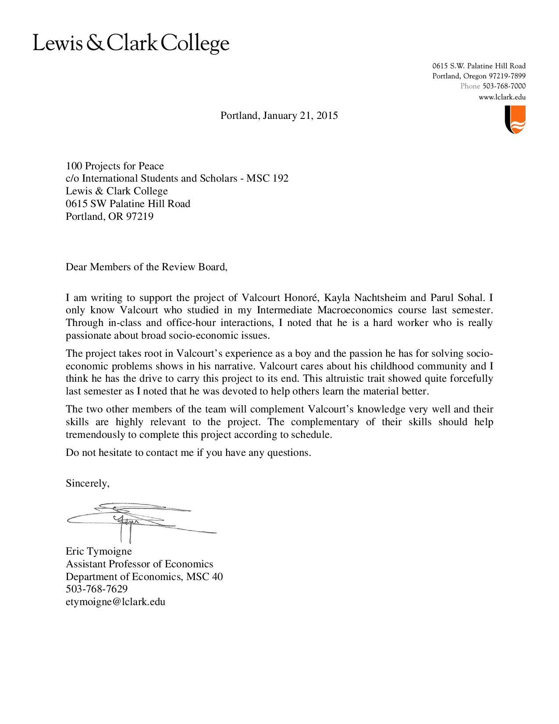
Letter from Director of Le Village des Petits Princes
Pastor Pierre Milord has been directing Le Village des Petits Princes school and running its summer program for 20+ years.

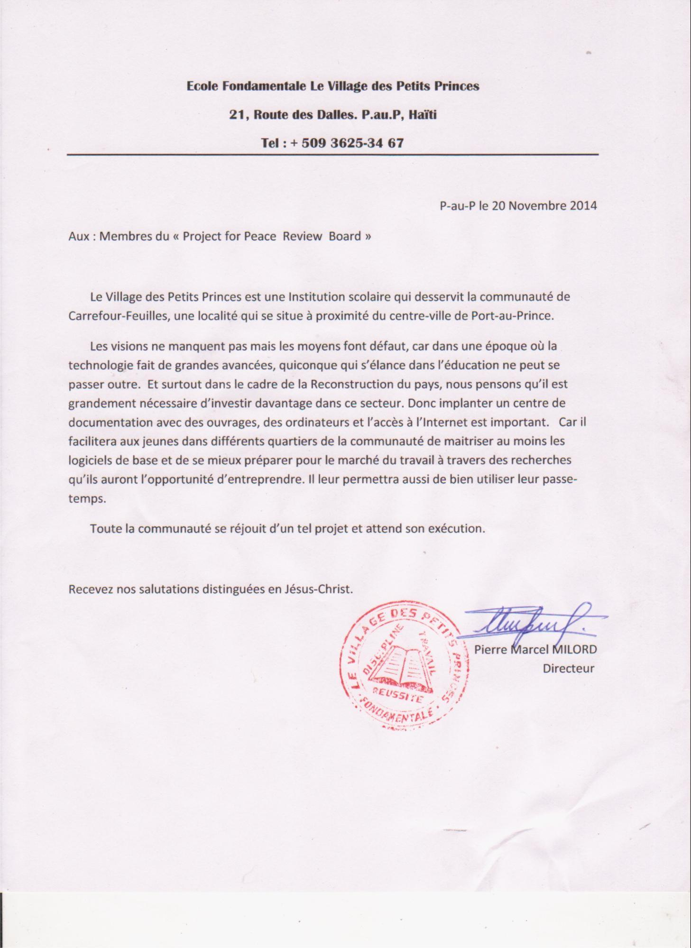

Translation of the letter

Le village Des Petits Princes Primary School
21, routes des dalles, P-au-P, Haiti
___________________________________________________________________________________________________________________________________________________

P-au-P, November 20th 2014

To : Members of the Project for Peace Review Board

Le Village des Petits Princes is an academic institution that serves the community of Carrefour-feuilles, a neighborhood situated near the center of Port-au-Prince.
The visions we have for this institution for this community abound but the financial means are lacking because in a time when technology is making great strides, anyone who pursues their education cannot be successful without technology. And especially in the context of the reconstruction of our country, we believe there is a great need for more investment in the technological sector. Thus, establishing a computer center with useful curriculum for instruction, computers, and access to the Internet is important. Since it will allow young people from different areas of the community to master the basic software and to better prepare for the labor market through research that they will have the opportunity to undertake. It will also enable them to effectively use their free time.
The whole community is looking forward to this project and is awaiting execution.
Receive our best regards in Jesus Christ’s name.

Pastor Pierre Marcel Milord
School head

Letter from Capitol Child Development Center
Capitol Child Development Center is an accredited non-profit organization subset of Compassion International working in Carrefour-feuilles for over 40 years to deliver children from poverty. They support educational fees and organize social events for young people in Carrefour-feuilles.
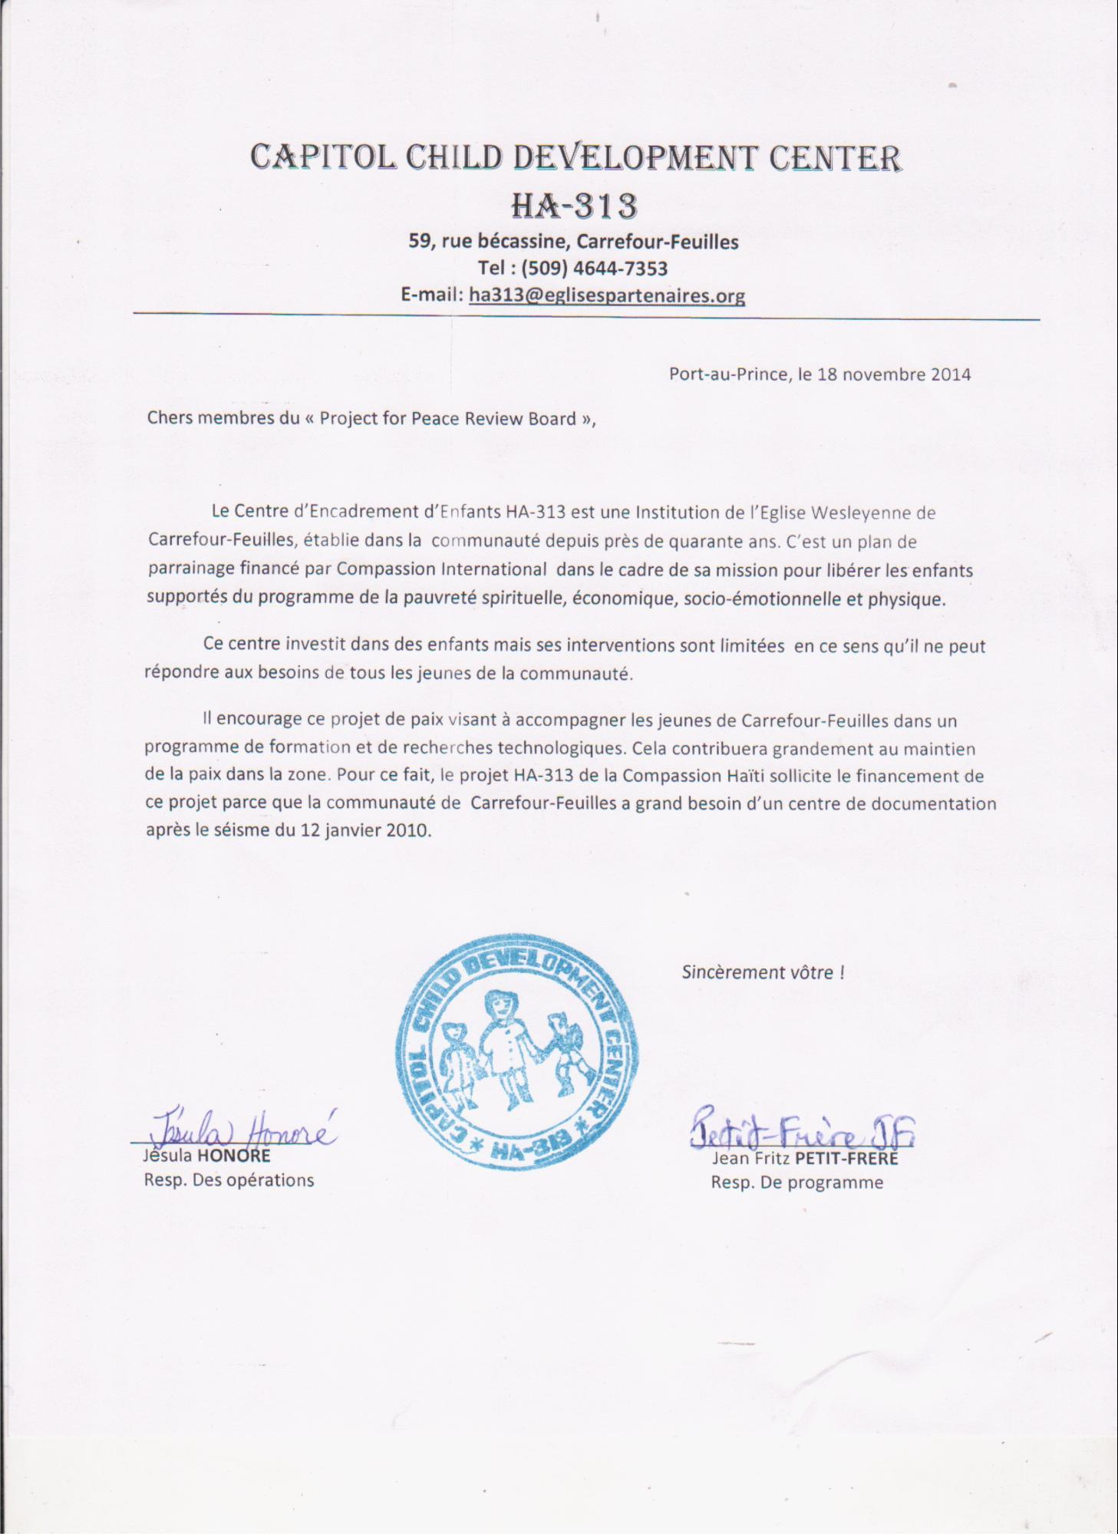

Translation of the Letter

Capitol Child Development Center HA-313
59, Becassine Street, Carrefour-feuilles, P-au-P, Haiti
Tel: (509) 4644-7353
E-mail: ha3136eglisespartenaires.org
___________________________________________________________________________________________________________________________________________________

P-au-P, November 18th 2014

Dear members of the Project for Peace Review Board,

The Center for Children HA 313 is an institution of the church of Wesleyan Carrefour Feuilles established in the community for nearly forty years. It is a sponsorship plan financed by Compassion International as part of its mission to free children from spiritual, economic, socio-emotional and physical poverty.
The center invests in children, but its actions are limited in that it can not meet the needs of all youth in the community.
In that sense, it encourages this peace project aimed at supporting these youth through a summer program with technological research opportunities. This will greatly contribute to the maintenance of peace in the area. For this, the HA-313 Haiti Compassion Center seeks funding for this project because the community of Carrefour-feuilles is in great need of a computer center after the earthquake of January 12, 2010.

Sincerely yours!

Jesula Honoré

Jean Fritz Petit-Frère

Letter of proof that the administration of Le Village des Petits Princes has agreed to pay a teacher that we will train to be a full time worker at the computer lab permanently.

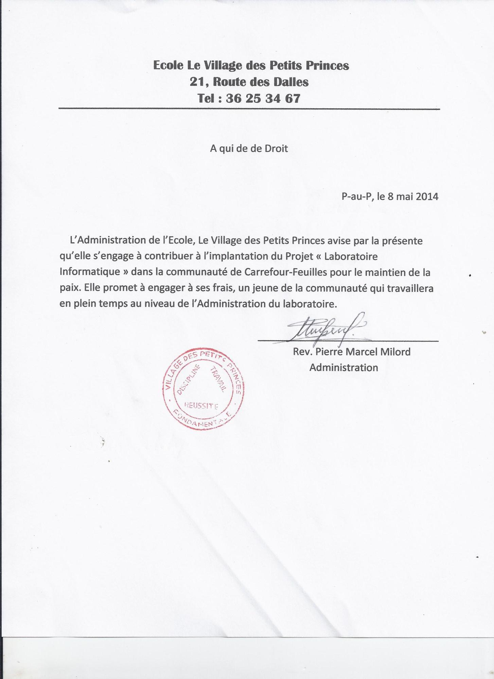

Translation of the Letter

Le Village des Petits Princes Primary School
Address: 21, Route des Dalles
Tel : 36 25 34 67
________________________________________________________________________________________________________________________________________________________________________

To whom it may concern

Port-au-Prince, May 8th 2014

The Administration of Le Village des Petits Princes primary school hereby gives notice that it agrees to contribute to the implementation of the project "Computer center" in the Carrefour-Feuilles community for the promotion of peace. It promises to engage at its expense, a young person from the community who will work full time at the Administration of the computer center.

_______________________________________________
Rev. Pierre Marcel Milord
Administration

Letter from the 4 teachers that we will train so they can use the curriculum to lead the program in future years.

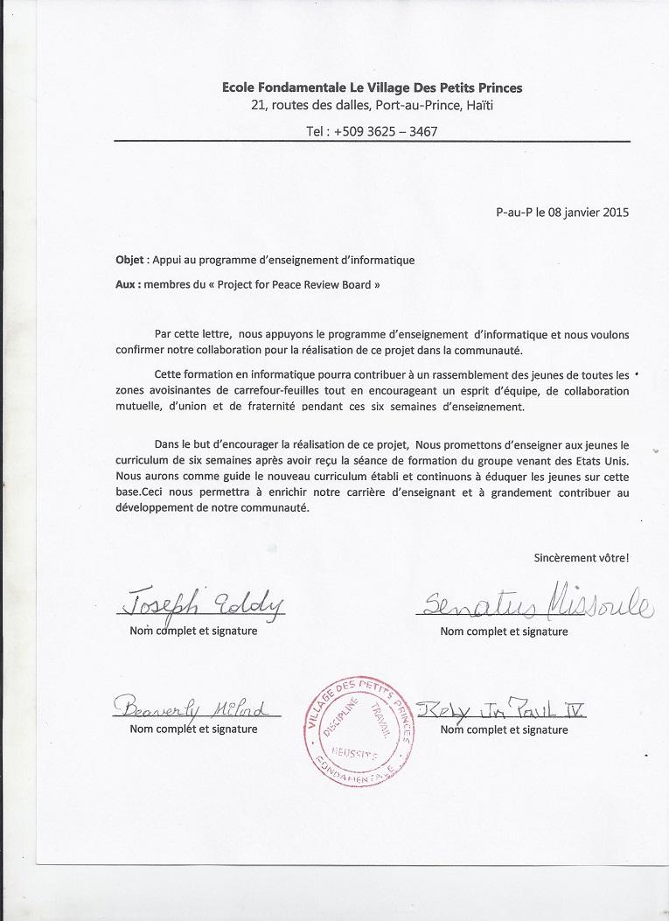

Translation of the Letter

Le Village des Petits Princes Primary School
Address: 21, Route des Dalles
Tel : 36 25 34 67
________________________________________________________________________________________________________________________________________________________________________

Subject: Support for the computer education curriculum

To: Members of the "Project for Peace Review Board" ,

With this letter, we support the computer education program and we want to confirm our collaboration for the achievement of this project in the community.
This computer training will contribute to a gathering of young people from the surrounding areas of Carrefour-feuilles while encouraging teamwork, mutual cooperation, unity, and brotherhood during those six weeks of learning together.
In order to support the completion of this project, we promise to teach young people the six week curriculum after receiving the group's training session from the Lewis & Clark College students. We will have as guide the newly established curriculum and continue to educate young people on this basis. This will allow us to enrich our teaching career and contribute greatly to the development of our community.

Sincerely yours!

Signed by:

Joseph Eddy

Senatus Missoule

Beaverly Milord

Relly Jean Paul IV

Appendix: Curriculum Information

Computer Education Curriculum
Our curriculum is based on research into strategies for restorative peacebuilding and experiential learning with the help of local experts. We are working with OMBUDS representative Valerie White among others to develop a curriculum that addresses intolerance in the classroom. We have reached out to staff at organizations doing similar work in Haiti(What If? Foundation, Hands Together of the Palm Beaches, the DREAM Project, etc.), companies that sponsor computer centers (IBM, Intel, etc.), and Lewis & Clark Departments of Computer Science and Information Technology to assist us in creating our curriculum. If selected we are planning on reaching out to the Lewis & Clark Graduate School of Education for further guidance.

Some of the strategies we will use to promote peace in our classroom include:
- 5 minute ‘warm ups’ at the beginning of each class and occasionally between activities. These will involved questions like “What makes you feel comfortable in a group of people you don’t know?”, “How do you know that your work is appreciated?”, “What does it look like to be listened to?”, etc. These exercises will get students talking with one another and make them feel more comfortable participating.
- Group Task Rotation. When students are working in larger groups of four we will help them delegate the tasks of an activity. Throughout the activity students will be required to switch tasks with another group member. This will allow everyone in the group to equally participate in each class exercise. It will also help them recognize their strengths.
- Post-activity chat. After each activity is completed a student will find one of their peers in a different pairing to discuss their impressions of the activity and what they learned.

We will teach ages 11-14 (see grey in table) three times per week Wednesday, Friday, and Saturday. We will teach ages 15-20 (see white in table) two times per week Thursday and Saturday. All classroom sessions will last one hour. The content and learning objectives of classes for the older group will be different in terms of the pacing of the material. Below is our preliminary curriculum for the two groups.
Weeks | Lesson | Learning Objectives | Peace Promotion | Outside Classroom Assignments
WEEK 1  July 13-18  (ages 15-20) | Welcome!: Introduction to Windows, Paint, Microsoft Word, Powerpoint | -Students make nametags for their partners based upon partners’ preferences.  -Learn components of computer and its basic operational functions.  -Microsoft Word free writing to define peace as they understand it with their partner.  -Find Commonalities game in student pairs and Powerpoint about commonalities in small groups. | -Students get to know each other, us, and the four summer teachers.  -Students set class agreements & expectations collectively for a peaceful learning environment.  -We measure class’ understanding of peace at start of the program. | Personal goal setting for this program, Interview family members about what peace means to them, Information sheet about Windows
WEEK 1  July 13-18  (ages 11-14) | Welcome!: Introduction to Windows, Paint, Microsoft Word | -Students make nametags for their partners based upon partners’ preferences.  -Learn components of computer and its basic operational functions.  -Introduce your Partner game.  -Microsoft Word acrostic poem about peace in pairs and share with class. | -Students get to know each other, us, and the four summer teachers.  -Students set class agreements & expectations collectively for a peaceful learning environment.  -We measure class’ understanding of peace at start of the program. | Personal goal setting for this program, Interview family members about what peace means to them, Information sheet about Microsoft Word and Paint
WEEK 2  July 20-25  (ages 15-20) | Contemporary Affairs, Android applications, and Prezi | -Student pairs create a testable application with makemedroid.com and share in small groups.  -In-class discussions of contemporary controversial issue in the community/Port-au-Prince.  -Outside class community survey related to discussion conducted by student pairs. Data compiled into graphs and a Prezi presentation. | -Students practice giving constructive peer evaluation.  -Students openly listen to others’ ideas about issues in their community.  -Student pairs cooperate outside of the classroom. | Community Survey, Information sheet about Prezi and the Android application
WEEK 2  July 20-25  (ages 11-14) | Research and Share!: Introduction to internet research & Powerpoint | -Interview a partner about a personal story.  -Practice quality internet research to add details & images about that personal story to Powerpoint presentations to share with the class. | -Students practice active listening and build trust by sharing personal stories.  -Students enrich their stories and others’ through research and presentation. | Information sheet about Powerpoint
WEEK 3  July 27-Aug 1  (ages 15-20) | Best practices for internet research and Curriculum Vitae (C.V.) writing | -Interview a partner about a personal story.  -Practice quality internet research to add details & images about that personal story to Powerpoint presentations to share with the class.  -Create their own C.V. in the standardized format and and edit their peers’ C.Vs. | -Students practice active listening and build trust by sharing personal stories.  -Students enrich their stories and others’ through research and presentation.  -Students work in pairs get to know each other’s personal stories and offer helpful advice. | Midway evaluation of the program, Information sheet about Internet research and C.V. writing
WEEK 3  July 27-Aug 1  (ages 11-14) | Cheep, growl, scratch: All about animals & fun with the Scratch program | -Participate in “Scratch” interactive coding site’s games related to animals.  -Animal Instincts game about conflict.  -Point of View Elephant Story Activity. | -Through a mix of interactive and online games, students are encouraged to be open to others’ points of view. | Midway evaluation of the program
WEEK 4  August 3-8  (ages 15-20) | Final Group Project preparation: Make a website! | -Small groups of 4 come to a consensus on final project topic based on field trip observations.  -Introduction to basic HTML syntax.  -Small groups create a website for their final projects. | -Students practice consensus model of decision-making and group delegation of tasks. | Field Trip and worksheet to fill out in student pairs at the museum, Information sheet about HTML
WEEK 4  August 3-8  (ages 11-14) | Final Group Project preparation: Make a website! | -Small groups of 4 come to consensus on final project topic based on field trip observations.  -Introduction to basic HTML syntax.  -Small groups create a website for their final projects  -Who’s got my duck teambuilding activity. | -Students practice consensus model of decision-making and group delegation of tasks.  -The class works collectively and in small groups to achieve a common goal.  -The class works collectively and in small groups to achieve a common goal(Who’s got my duck game). | Field Trip and worksheet to fill out in student pairs at the museum
WEEK 5  August 10-15  (ages 15-20) | Final Group Project Continued: Social Media & Diverse Truths | -Introduction to blogger.com funcions.  -Small groups create a blog together for their final projects.  -Internet research activity for material for blog posts.  -Truth or Truth trust building activity. | -Students explore social media as a form of personal expression and way to engage with diverse personal truths. | Information sheet about advanced funcions of blogger.com
WEEK 5  August 10-15  (ages 11-14) | Final Group Project Continued: Social Media & Diverse Truths | -Introduction to blogger.com funcions.  -Small groups create a blog together for their final projects.  -Internet research activity for material for blog posts.  -Truth or Truth trust building activity. | -Students explore social media as a form of personal expression and way to engage with diverse personal truths. | Information sheet about basic funcions of blogger.com
WEEK 6  August 17-20  (ages 15-20) | Final Group Project last preparations: Present and evaluate each other | -Small groups create a Prezi on their final project topics.  -Work as a class to create an evaluation sheet for practice presentations in preparation for final celebration.  -Students provide constructive feedback for their classmates’ benefit.  -Anonymous affirmation activity for students to take away with them. | -Students gain experience presenting among peers of different backgrounds.  -Students practice giving constructive feedback that is helpful, not hurtful.  -Students are encouraged to affirm what their peers have contributed to their own experience in the program.  -Students share their new perspectives and skills with friends, family, and community. members at the final celebration. | End of program surveys about what they have learned and future suggestions for the program, final celebration presentations
WEEK 6  August 17-20  (ages 11-14) | Final Group Project last preparations: Present and evaluate each other | -Small groups create a powerpoint on their final project topics.  -Work as a class to create an evaluation sheet for practice presentations in preparation for final celebration.  -Students provide constructive feedback for their classmates’ benefit.  -Anonymous affirmation activity for students to take away with them. | -Students gain experience presenting among peers of different backgrounds.  -Students practice giving constructive feedback that is helpful, not hurtful.  -Students are encouraged to affirm what their peers have contributed to their own experience in the program.  -Students share their new perspectives and skills with friends, family, and community members at the final celebration. | End of program surveys about what they have learned and future suggestions for the program,, final celebration presentations

Curriculum Research Resources we have found helpful and will use in finalizing our curriculum:

- http://teacherstryscience.org/
Provided by IBM

- http://teacherstryscience.org/kids
Provided by IBM

- https://www.ibm.com/ibm/responsibility/initiatives/activitykits/
Provided by IBM

- http://www.peacefirst.org/digitalactivitycenter/

- http://peacefirst.org/digitalactivitycenter/files/rituals_toolkit_10.30.2012_0.pdf

- http://www.digitalliteracy.gov/

- http://www.uniqueteachingresources.com/

- http://spclc.org/curricula-resources/computer-curriculum

- http://www.microsoft.com/about/corporatecitizenship/citizenship/giving/programs/up/digitalliteracy/default.mspx

- http://www.webjunction.org/explore-topics/computer-internet-basics.html

- http://csunplugged.org/

- http://scratch.mit.edu/

- http://www.e-learningforkids.org/computer-skills/

- http://www.teachpeacenow.org/

- http://www.teacherplanet.com/

- http://www.cyark.org/education/

Appendix: Measurement and Evaluation Information

Sample questions Student Evaluation (start of program):
- What do you hope to learn through this program?
- What experience do you have with computers?
- How do you work with others who don’t share your perspectives?

Sample questions Student Evaluation (middle of program):
- What have you learned through this program so far?
- What have you learned from working with your partner(s) and what challenges have you faced?
- What were your favorite activities in the past weeks?
- What would help you feel more comfortable in the classroom?

Sample questions Student Evaluation (end of program):
- What have you learned through this program?
- What would you like to see added to the curriculum for future summer programs?
- Give an example of when your class partner was particularly helpful in your work?
- What challenges did you face working with a group on your final project and what did you learn?

Sample questions Teacher Evaluation (start of program):
- What strategies have you developed in the classroom to work with students from different backgrounds?
- What challenges do you foresee with this computer education curriculum?
- What would you like to see added to this curriculum?

Sample questions Teacher Evaluation (middle of program):
- How have the group of students you have observed interacted with each other?
- What have you found the most effective for integrating students from different backgrounds in the classroom?
- How would you suggest increasing positive interactions between students?

Sample questions Teacher Evaluation (end of program):
- How have you seen the students’ attitudes about their classmates tangibly change?
- What strategies have been most helpful to break down barriers between students?
- How would you alter this curriculum for future summer programs?

Appendix: Computer Center Specifics
Le Village des Petits Princes is located at 21 Route de Dalles, Port-au-Prince. The room that we will use for our center is approximately 35 square meters and will be locked when not in use. See pictures below.
The staff have agreed to hire a teacher trained through our summer program to run the center full-time throughout the year. The center will be accessible to community members who sign up for a free membership and sign the center’s terms of use agreement. We will develop this agreement with Le Village des Petits Princes’ staff this spring.
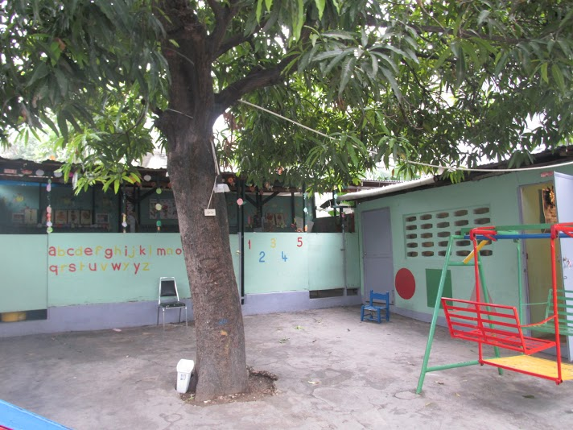
(Classroom we will use is at right)
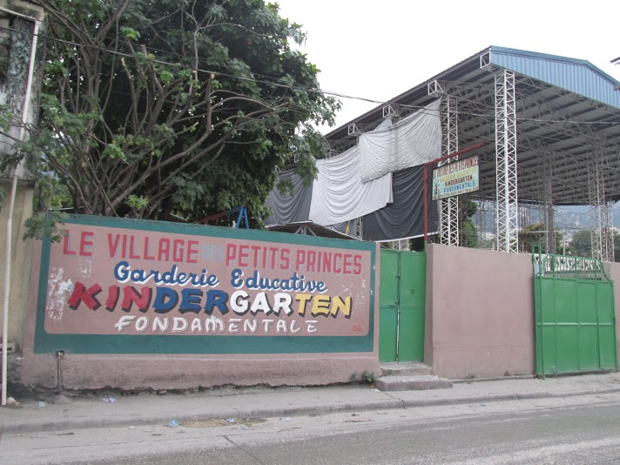
(front of school)

Appendix: Additional support from our contacts
We would like to thank the following individuals who have given us support throughout this project:

Nancy Anderson, President and Founding Director, Hands Together of the Palm Beaches(HTPB). Nancy’s work with HTPB supports Haitian families in both the U.S and in rural Haiti with basic educational, financial, and medical needs. She is providing us with valuable curriculum resources from their Computer Education Program in Jeandenis, Haiti, as well as grant writing advice.

Kim Cameron-Dominguez, visiting Assistant Professor, Lewis & Clark College. Kim provided us with lots of support with editing our proposal and thinking through our ideas.

Cari Bacon Flick, second Vice President IDI operations, Individual Disability. She has helped with community outreach for our project.

Maria Eugenia Gallitelli, Latin American Coordinator, InterConnection.org. Maria has worked with us to get a discounted rate on laptops and is helping us plan a fundraiser e-waste drive on our campus to provide added funding for our project.

Jésula Honoré, Administrator, Capitol Child Development Center, Port-au-Prince. Valcourt’s sister Jésula has been an important source of support for this project in helping identify materials costs, accommodations while we are there, etc.

Élimène Jean, Valcourt’s mom, has helped provide cost estimates for our budget and advice about where to buy materials in Haiti.

Michael Kaplan, Managing Director of the Center for Entrepreneurship, Lewis & Clark College. Michael has been helpful in connecting us with rising business leaders in the area and encouraging entrepreneurial innovation in our project.

Janna Katz, Kayla’s mom, has helped with proposal editing and brainstorming.

Jens Mache, Professor of Computer Science, Lewis & Clark College. Jens has helped us in the initial stages of our project in theorizing how to develop a computer education program.

Pierre Marcel Milord, Director, Le Village des Petits Princes School and Summer Program. The Pastor has been our principal contact with Le Village des Petits Princes and as a respected leader in the community he is committed to ensuring the sustainability of this project.

Rubénite Milord, academic director at Le Village des Petits Princes. She has supported with price estimated and information about Le Village des Petits Princes school.

Molly Robinson Kelly, Professor of French Studies and Department Chair of Foreign Languages and Literatures, Lewis & Clark College. Molly has been a tremendous help with proposal editing as representative of the French Department.

Patrick Ryall, Director of Operations Information Technology, Lewis & Clark College. Patrick is helping us with the campus computer equipment drive we are planning by contributing old equipment that IT collects frequently and donating it to our drive.

David Slavin, volunteer with the DREAM Project, which operates a computer education program in schools in the Dominican Republic, has been very helpful in working to get us sample curriculum ideas from what the organization has used for their lesson plans.

Margaret Trost, Founder, “What If? Foundation.” She heads a foundation that has worked with the Ti Plas Kazo community of Port-au-Prince to provide food and educational opportunities to underserved children for the past 15 years. Margaret supports our project and said in a discussion with us “praying for unity is something that is very important for Haitians, and people coming together is part of that prayer…unity brings peace.”

Eric Tymoigne, Professor of Economics, Lewis & Clark College. Eric has given feedback on our proposal and write us the recommendation letter as representative of the Economics Department.

Valerie White, OMBUDS person, Lewis & Clark College. Valerie has provided us with valuable curriculum support and editing support. As a great supporter of our project she has articulated “peacebuilding starts with people listening to each other.”

Linda Wilson, IBM Corporate Citizenship & Corporate Affairs Manager. Linda has provided us with IBM curriculum materials and has expressed interested in a partnership with our project and IBM.

www.peacefirst.org/digitalactivitycenter/files/commonalities.pdf
http://www.peacefirst.org/digitalactivitycenter/files/animal_instincts_1.pdf
http://www.teachpeacenow.org/pointofview.html
http://www.peacefirst.org/digitalactivitycenter/files/truth_or_truth.pdf
http://www.mohhaiti.org/about_haiti#.VIJMimTF_9s
https://www.cia.gov/library/publications/the-world-factbook/geos/ha.html
Ages recommended by Director of the summer program, Pastor Milord
See appendix Measurement and Evaluation Information for sample questions.
Kayla will help prepare presentations by working with Parul and Valcourt remotely as she is graduating this spring.

