Resala Charities: Teamwork Through Verbal Communication, Leadership, and Goal Achievement

Egypt

Lewis & Clark College

Hamdan Alameri, United Emirates, Lewis & Clark College; Reham Bahauddin, Saudi Arabia Lewis & Clark College; Isabella Irtifa, United States, Lewis & Clark College; Jessica Roseblatt, United States, Lewis & Clark College; Burnley Truax, United States, Lewis & Clark College

The primary goal of our project was to provide teamworking tools for children and youth in Cairo, Egypt by introducing and building upon skills targeting three main components of teamwork being communication, leadership, and goal setting. Our project provided a space to generate and share ideas in the forms of stories, values, beliefs, interests and goals, broadening each of our communities to stretch across the world. We had three additional funding sources in addition to the Davis Foundation, which included the Lewis & Clark Student Government Finance Committee, Greenhouse Scholars, and the President’s Office of Lewis & Clark College.
Despite three group members having minimal comprehension of arabic, each team member was able to comfortably communicate with the children, youth, advisors, and head staff from Resala using creative methods with gestures, sounds, and movement. A significant factor in this was Resala’s willingness and openness to collaborate and participate in the teambuilding activities. Before arriving to Resala, our group felt equipped and confident in our respective experiences working in teams to lead a summer camp program focused on teamwork. We quickly realized the complexity and difficulty of implementing concepts of our program into our own group. Participants of the camp, including Resala children, youth, advisors, and the administrative staff at Resala, and our Lewis & Clark group began to interact with and embody the multifaceted components of teamwork. Throughout our program we explored the fluidity of leadership by exploring how to find and fill roles, requiring everyone in our group and of the Resala community to be a leader in a particular moment. We interacted with these pillars of teamwork through activities, discussion, and reflection, within a variety of combinations of teams, challenging and exploring the significance of exercising these to accomplish a task. Throughout this program we witnessed Resala’s positive energy and creative spirit through spontaneous dance parties, campfires, and proposing clever solutions.
We aim to apply another long-term impact of our program by generating a bond between Resala Charities and Lewis & Clark College, also constructing a summer camp template and structure, with activity and games to enhance team building skills. At Lewis & Clark we plan to organize a scholarship program to hopefully send a Resala resident to Lewis & Clark for one year to learn English in our Academic English Studies program (AES). Our teamwork summer camp program was informally and formally affirmed by Resala as being an enriching experience for everyone involved.
Peace is accepting differences and admiring diversity. Peace is the true love that we carry for others and the pure actions that come from good intentions. Building and sustaining peace starts with communities working together to engage in open and honest dialogue, nurturing relationships of trust and compassion rather than fear and hate. The Arab Spring reached Egypt in 2010, where political frustrations and discomfort came forward in youth protests across the nation. During and after the Arab Spring Egypt was completely transformed, increasing the number of children without homes and orphaned youth. The need for peace in Egypt starts with the children of the nation, as the children will one day be responsible for their communities and families. Our project worked directly with youth affected by homelessness and poverty, where we practiced learning experiences that teach the value of teamwork and goal setting as well as positive and reflective communication. On the final day of camp we held a career fair, inviting prominent leaders in the community to talk to the children and empower them to reach the goals they had set throughout the camp. The children engaged in forms of communication where all were able to voice their opinions and disagreements in mutually respectful ways, proving that cooperation and shared experience is powerful in identifying a common goal. The skills taught in these workshops will help advance the political stability in Egypt and other nations by enabling youth to work towards peaceful alternatives to conflict.
This project required all of us to think critically about one another and about the environments we are in. Being a part of the Egyptian community and invited by local community leaders to prayer and fast break was an incredible and moving experience. Such experiences allowed us to engage in interfaith and intercultural conversations, combating misconceptions and striving towards understanding, coming to love our differences and opportunities to learn from one another. As a group we were able to act as diplomats, representing countries around the world, including United Arab Emirates, Saudi Arabia, and the United States, building bridges and friendships for transnational peace. Coming back to the United States we now think deeply about the perceived sources of tension, and act as advocates for members of our community affected by marginalization. We hope that sharing our stories of blessed moments such as experiences during Ramadan, the strength of community in Egypt, and the beauty of all the individuals we have met will help to promote a more inclusive global community. We remember our experiences with gratitude and warmth, communicating with our friends in Egypt about how to make the world a better place. “We now understand that we have a duty to be peacemakers both globally and within our own communities, to take the care we have learned from the children and the Resala community to prove locally and internationally how to love and find truth” says Isabella Irtifa. Hamdan Alameri adds “This trip was a point in my life that shaped many definitions in my mind and gave me the chance to be somewhere I do not belong to know better how to belong everywhere and accept differences."

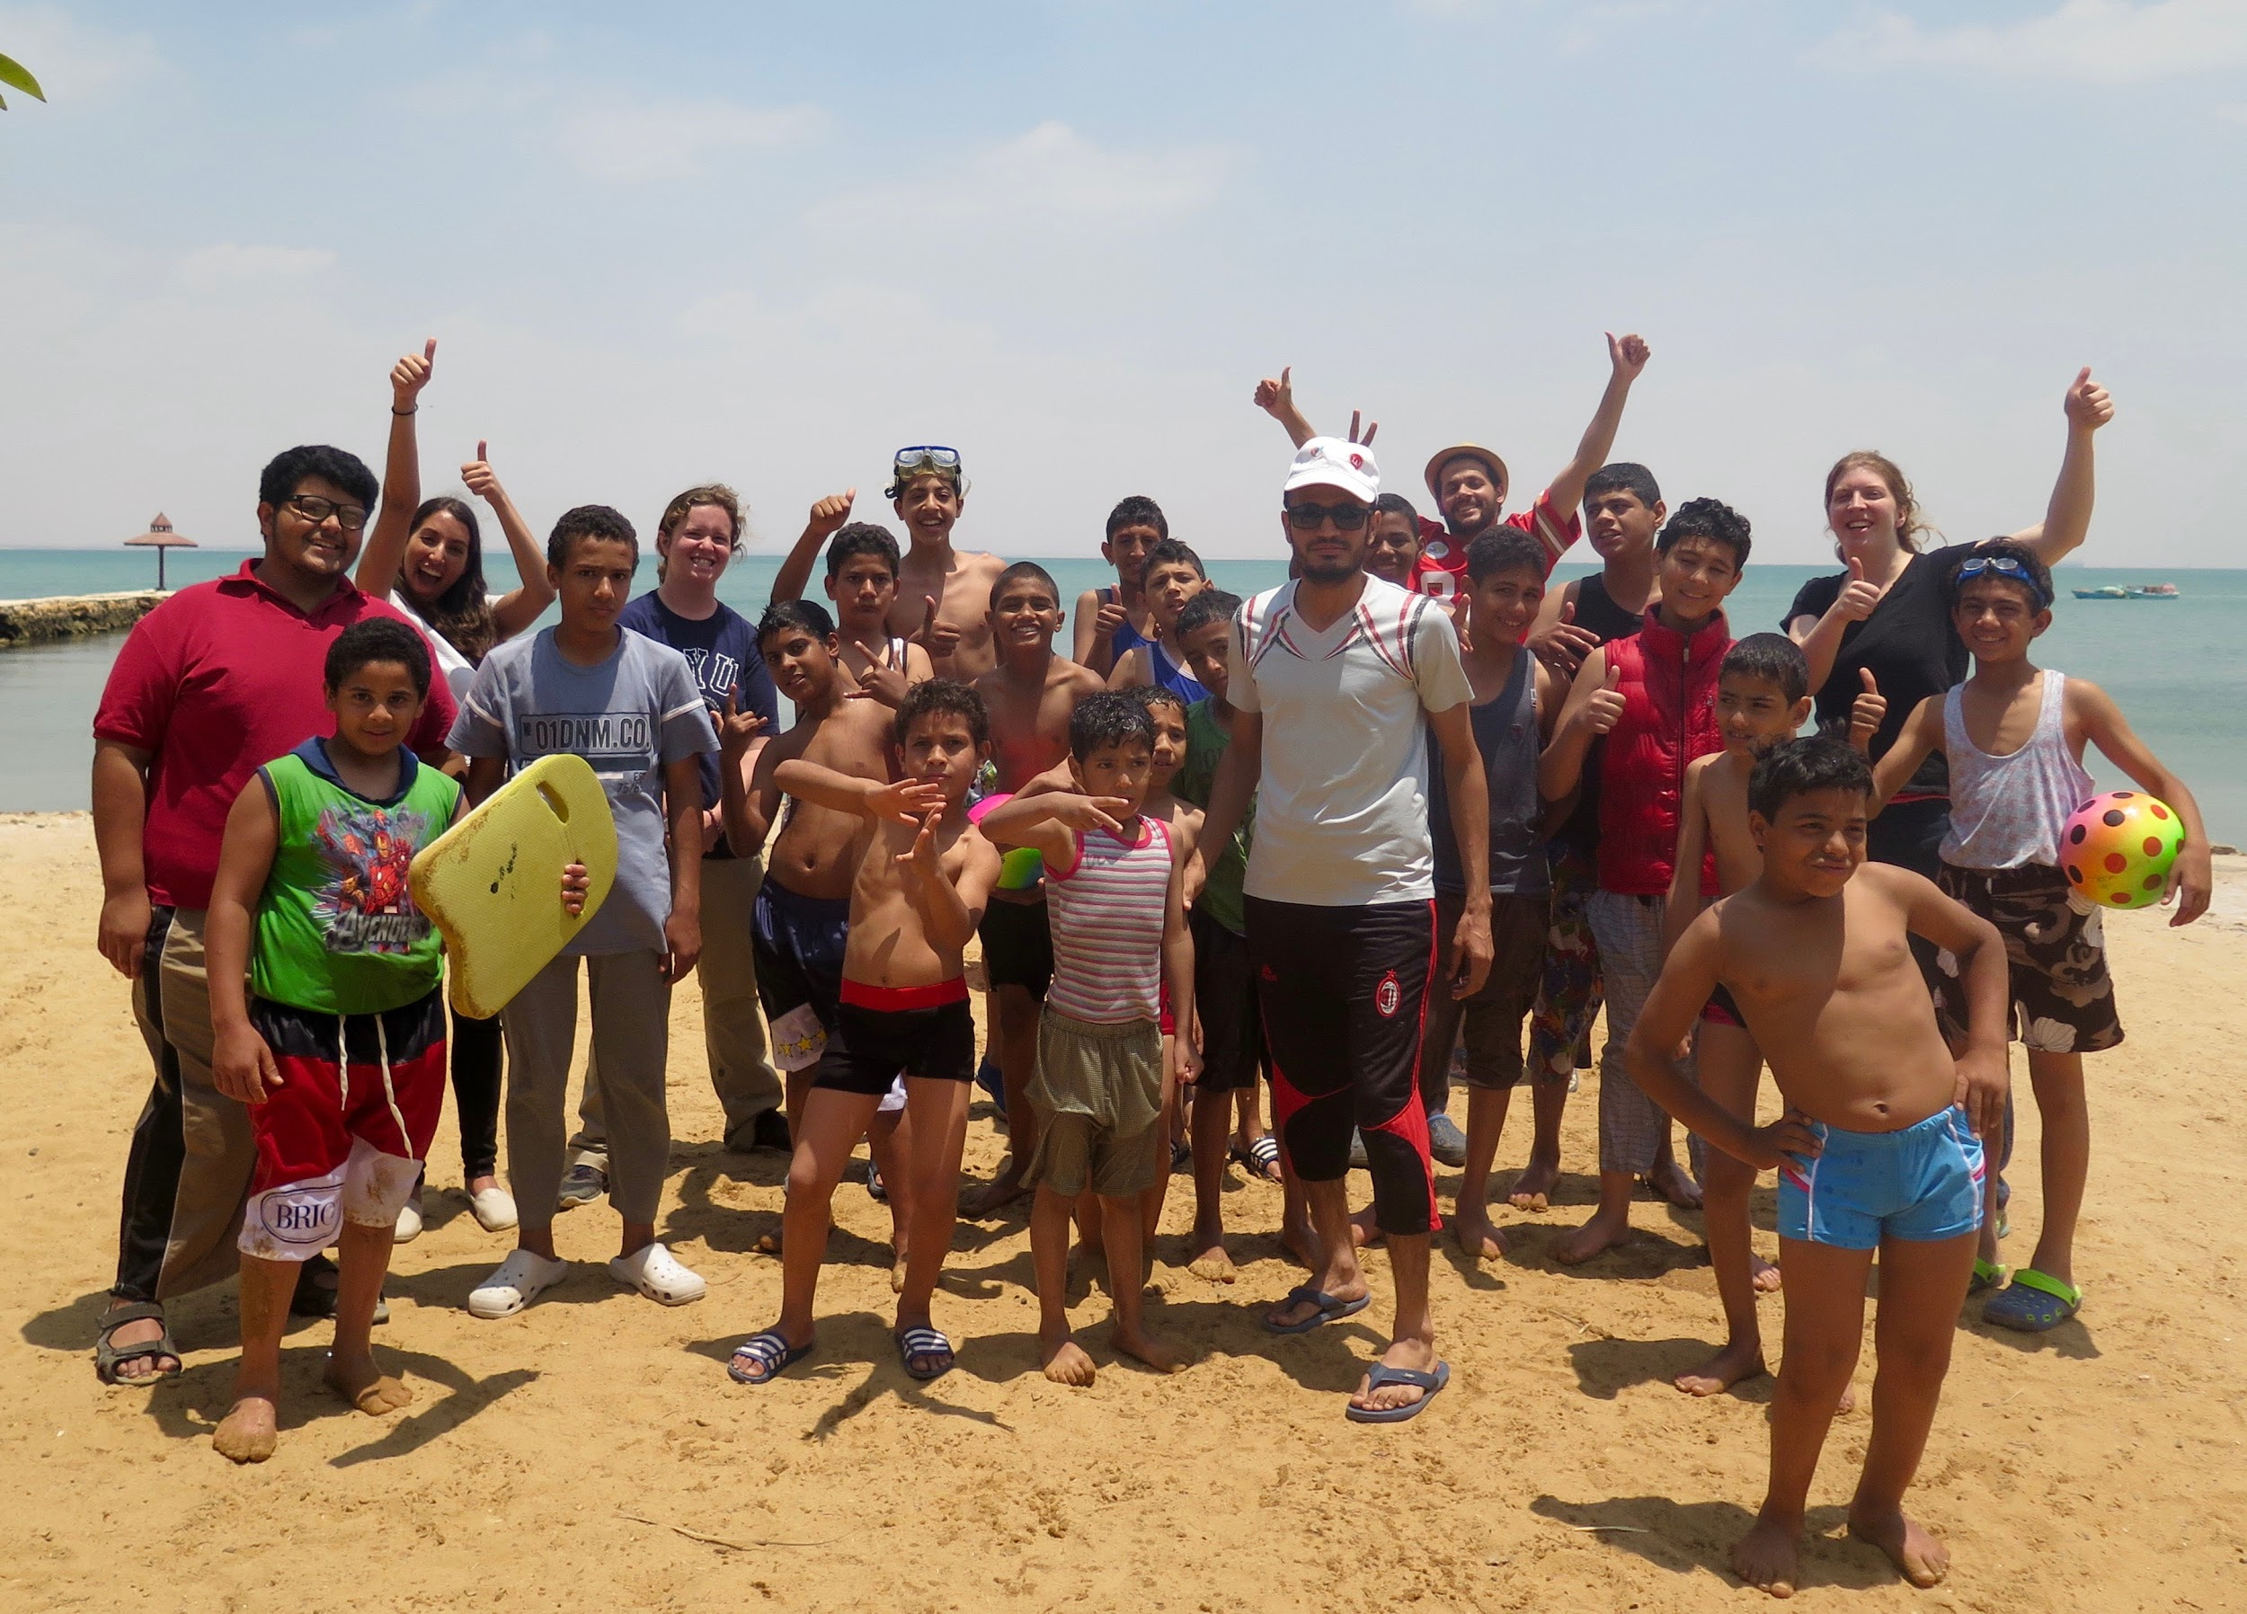
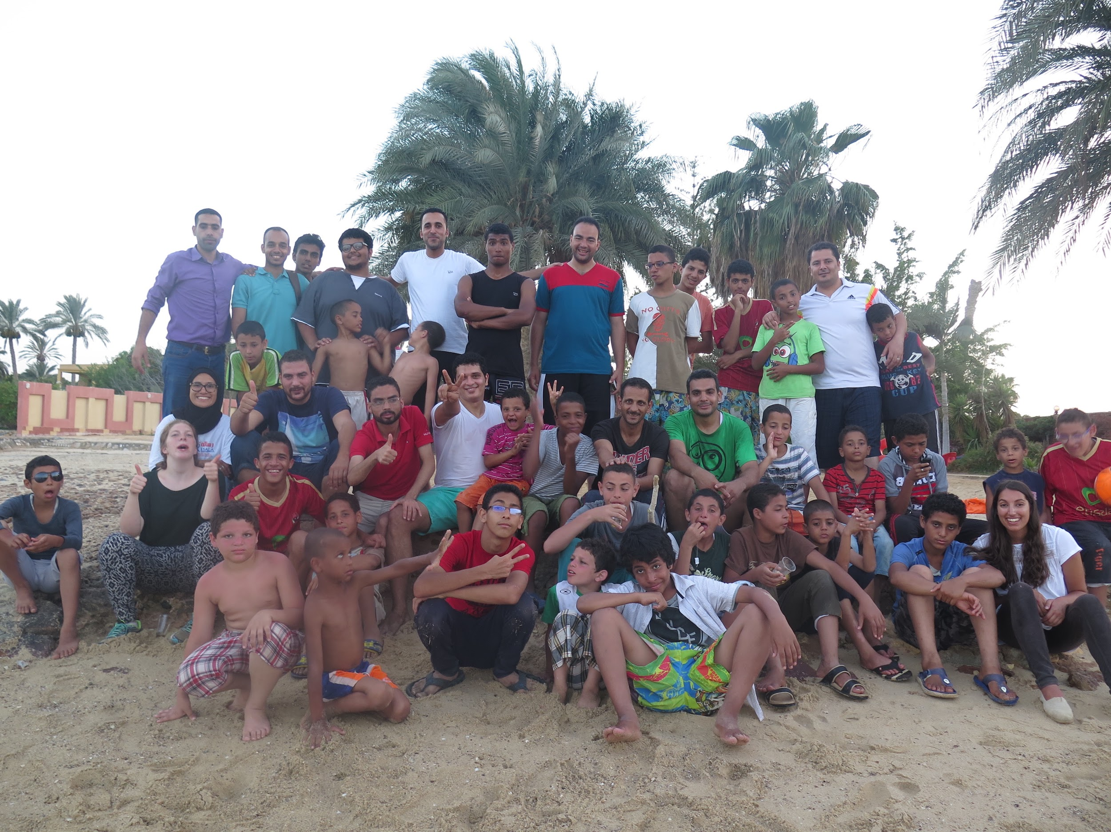
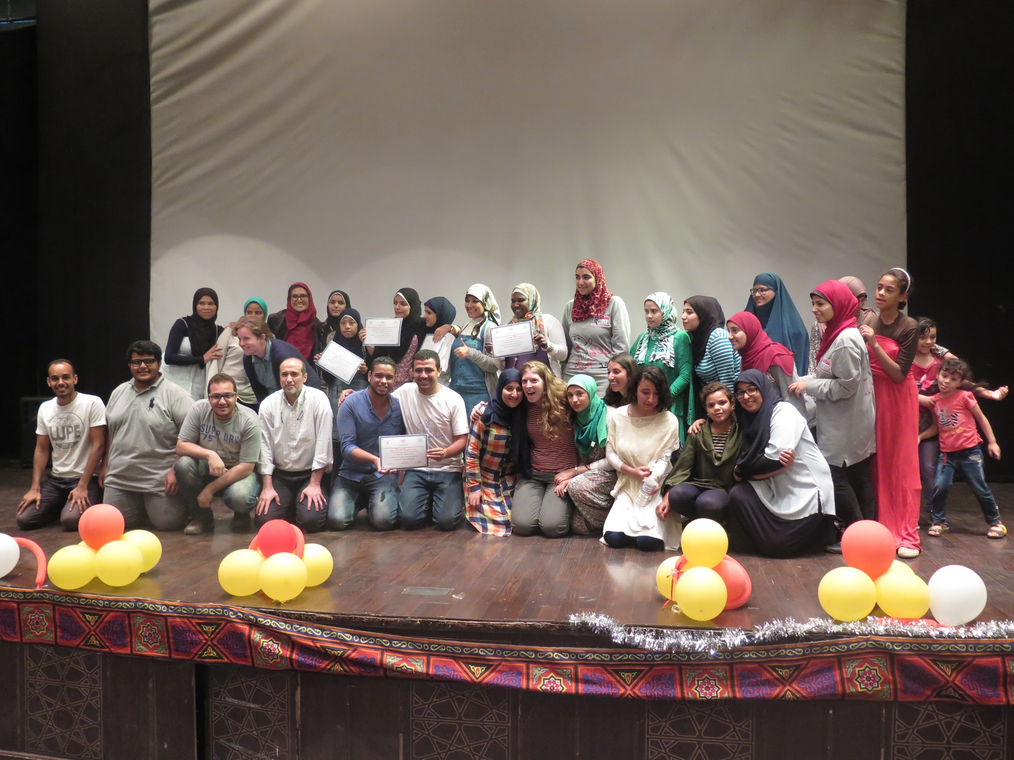

Final Expenditure Budget Spreadsheet:

Category | Item | Amount
Travel | Burnley's Plane Ticket | 1041.49
 | Isabella's Plane Ticket | $1168.06
 | Reham's Plane Ticket | $1710.96
 | Jessica's Plane Ticket | $1504.05
 | Hamdan's Plane Ticket | $314
 | Transportation | $134.25
 | Visas | $60
Total |  | $4259.56
Personal Living Expenses | Hotels/Housing | $2,091
 | Food | $554.10
 | Water | $50
 | Cell Phones | $45
Total |  | $2740
Charity Expenses | Meals | $1616
 | Water and Juice | $60
 | Trophies | $62.5
 | Decorations | $50
 | Certificates | $106.50
 | Gifts | $47.50
 | Bunk Beds | $3506.25
 | Mattresses | $1531.25
 | Pillows | $196.875
 | Televisions | $400
 | Projector, Speakers and Screen | $250
 | Stove | $87.50
 | Oven | $37.50
 | Fan | $50
 | Blender | $25
 | Kitchen Utensils | $35
 | Kitchen Tables | $112.50
 | Washing Machine | $62.50
 | Tent | $43.63
 | Electric Bug Killers | $20.5
 | Water Filters | $52.5
 | Transporting Supplies | $309.37
 | Other Camp Supplies | $397.87
Total |  | $11,845.745

Outside Sources of Funding
 | Lewis & Clark Student Government- Finance Committee | $5,500
 | Greenhouse Scholars | $2,000
 | Lewis and Clark President's Office | 2,000
Project Total: | $18,845.305

