100 Project for Peace Proposal 2021
#MoreThanAMinority: Reducing Discrimination Through Interactive Exhibitions
Jovo Janjetovic ’23, Lewis & Clark College
Background
Two decades after the war, Bosnia-Herzegovina is a divided society. The country has a major problem with reconciling its three major ethno-religious groups and there are still more than 99,000 internally displaced persons. Problems do not stop there. The Bosnian society is looking with disapproval at women active in the public sphere, the Roma minority is facing major problems in education and job opportunities, while the LGBT+ community is marginalized and faces daily scrutiny. On top of all of this, Bosnia-Herzegovina has been facing a steady influx of refugees as the country is a part of a Balkan transit route. There are more than 8,000 migrants currently situated in Bosnia-Herzegovina and this number has been steadily rising. These individuals continue facing an exponential increase in xenophobia.
Most of these problems are a direct result of ignorance. People have little exposure to the vulnerable groups. According to the Sarajevo Open Center research, only 1 in 10 people in Bosnia-Herzegovina knows someone who is part of the LGBT+ community. The research conducted by Friedrich Ebert Stiftung shows that 30 to 40 percent of the people in Bosnia-Herzegovina see migrants as a political, cultural or economic threat. Only 2,4% of children would accept to be seated next to a Roma child. This data shows that the aforementioned marginalized groups are still perceived as the “invaders” in the Bosnian society.
A solution that proved to be successful in tackling prejudices toward minority groups is the exposure to their stories and experiences. In psychology, this is known as the ‘contact hypothesis’ and was shown to be beneficial in projects of reconciliation and reducing prejudice. The project will utilize the mentioned phenomenon in order to bring experiences of these marginalized groups to the Bosnian youth. This will be reinforced with an interactive “escape room” that will be based on barriers and obstacles that minorities face daily. The visitors will experience these problems firsthand through the interactive game. The project will be documented through a movie that will reach broader audiences.

Project Description
The project consists of three main parts: the gallery and the escape room (the interactive exhibition), and the video testimony / movie. Together these parts will make an interactive audiovisual exhibition. The interactive exhibition will come to life in four major cities across Bosnia-Herzegovina (Sarajevo, Banjaluka, Tuzla and Mostar) and two cities in neighbouring Serbia (Belgrade) and Croatia (Zagreb). Target audience are college students and graduates, along with young people entering their careers and forming their opinions on matters relevant to marginalized groups. Symbolic promotional and educational packages will be marketed and given to randomly selected attendees as an incentive to visit the gallery in order to widen the scope of participants.

Escape Room
The escape room is an interactive game with the goal of escaping out of a room in which one is trapped. The escape room featured in this project will be centered around the stories and experiences of marginalized groups (primarily refugees) in Bosnia-Herzegovina. The visitors of our interactive galleries will have an opportunity to see for themselves what kind of obstacles marginalized groups face in their everyday activities. Two to six people will enter the room with a goal of “escaping” within 60 minutes, while being immersed into the life of a marginalized individual. They will have the challenge of filling out the forms that refugees are obligated to complete without understanding the language; to collect documentation that Roma people routinely have to show in order to do simple things like getting a birth certificate for their children. This would directlly confront the visitors with the daily discrimination that these groups face in Bosnian society.

Gallery
The gallery will accompany the escape room and it will consist of 30 objects that will be accompanied with testimonies of their owners (primarily refugees in Bosnia who will be reached with the help of the International Organization for Migration). Each story will explain how the object is connected to the life of its owner and it will tell personal stories of rejection, discrimination, or acceptence these people have experienced. This gallery is modeled on exhibitions of the War Childhood Museum (WCM) which presents stories of children who survived the Bosnian war together with the objects that they relate to these stories.

Video testimony / movie
Six different individuals from various marginalized groups will be filmed as they are telling their narratives about how their personal characteristics limited their life opportunities. Along with that, they will address the discrimination that they were subjected to. These video testimonies will be continuously streamed throughout each exhibition and they will provide visitors with an opportunity to see vulnerable faces and empathize with specific individuals. This is done in order to avoid visitors thinking of these people as an “outgroup”, but rather as their friends, neighbours, and family. A film and theater director will be in charge of making a short documentary out of these video testimonies as a part of our sustainability efforts. This short documentary will focus on portraying individual stories behind prejudice and discrimination.

Post-project Sustainability & Assessment
For the purpose of having a long-term impact on peace promotion, the project will start a media campaign #MoreThanAMinority which will be run on various social media, along with being publicized in the relevant cities. We will create social media accounts that are going to bring personal stories to people all around the region. After the project is completed, all the materials will be given to one of the partner organizations which expresses interest in continuing our work. Next to that, we plan that they will continue running the social media campaign, collecting personal stories, and sharing them with the world. Additionally, the movie will be submitted to film festivals and made available online with the aim of getting a greater audience exposure and increasing the project’s efficacy.
There will be an assessment of the project in order to measure its success in reducing the prejudice and harmful stereotypes toward marginalized groups. A psychology professor from Lewis & Clark College kindly agreed to provide guidance when it comes to administering the assessment which will include pre- and post- measurements of attitudes, along with the scale measuring one’s likelihood to immerse in the immersion games.

Project Objectives, Impact on Peace, and Timeline
The project aims to: (1) empower marginalized individuals who are the authors of the gallery pieces, (2) reduce stereotypes and prejudice of people attending interactive exhibitions toward refugees and other marginalized groups; (3) raise awareness of the general population about the obstacles that refugees and other groups face daily. By doing so, the project will promote peace through the reduction of prejudice and violence toward marginalized groups, and it will promote the idea of integration of refugees. Overall, we anticipate that around 800+ young people will go through the escape room (6-7 groups daily); along with that, many more would have the opportunity to visit galleries without directly participating in the game. These people will become advocates of spreading the messages of peace and cooperation.

Month | Week | Activity | Details
June | 1-2 | Institutional cooperation | Rent arrangements for each city finalized, video testimonies production team assembled, promotional campaign designed, cooperation with NGOs closely defined
June | 2-5 | Open call for the submission of gallery materials, interactive exhibition to be fully constructed | Promotion & media campaign starts, exhibition stories & items are being collected, construction of escape room finalized; exhibition conceptually created; filming the video material for video testimonies
July | 1 | Sarajevo interactive exhibition (IE) | Interactive exhibition - 5 days, development of the short documentary
July | 2 | Mostar IE | Interactive Exhibition - 5 days
July | 3 | Tuzla IE | Interactive exhibition - 5 days
July | 4 | Banjaluka IE | Interactive exhibition - 5 days
August | 1 | Zagreb (Croatia) IE | Interactive exhibition - 6 days
August | 2 | Belgrade (Serbia) IE | Interactive exhibition - 6 days; promotion of the short documentary

COVID-19 contingency: Masks, disposable gloves, hand sanitizers will be provided to participants. The escape room will be disinfected after each use. Separate entry points and exits will be provided, along with the limited maximum number of people in the venue at one time.

Project Budget

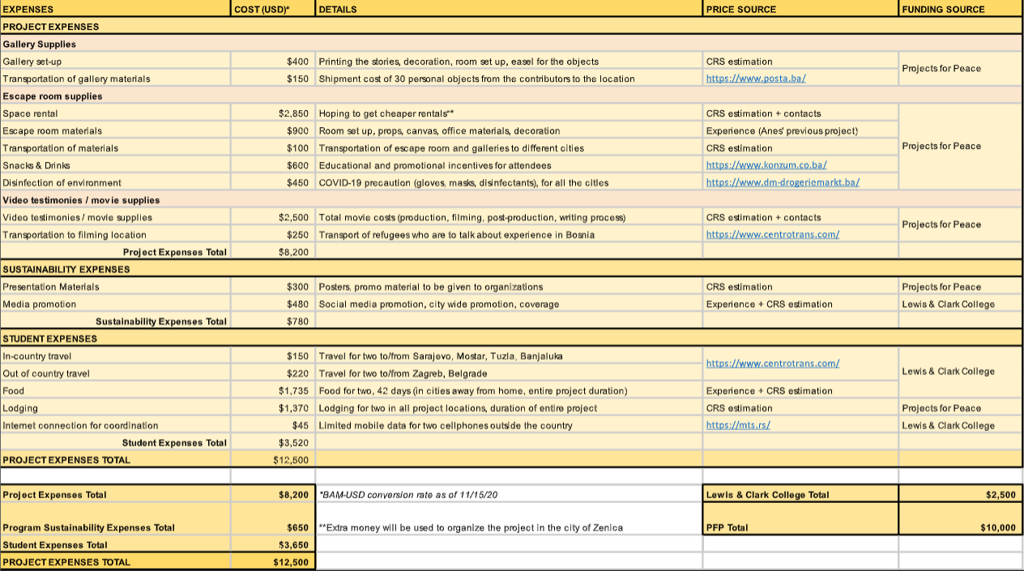

Bosnia and Herzegovina | IDMC (internal-displacement.org)
Bosnia and Herzegovina | European Civil Protection and Humanitarian Aid Operations (europa.eu)
https://soc.ba/oslobodenje-zivot-lgbt-osoba-u-bih-nije-jednostavan/
https://www.slobodnaevropa.org/a/30336168.html

