#MoreThanAMinority: Reducing Discrimination Through Interactive Exhibitions
Bosnia and Herzegovina
Lewis & Clark College
Jovo Janjetovic, Bosnia and Herzegovina, Lewis & Clark College, UWC in Mostar

Goal summary: This project aimed to empower marginalized individuals and the authors of the exhibition testimonies; reduce stereotypes and prejudice of people attending the interactive exhibitions against minority groups; raise awareness of the community about the obstacles that marginalized groups face on a daily basis.

External fundraising: Lewis & Clark College generously donated $2,500 to this project. This funding allowed for the creation of the escape room focusing on marginalized experiences in partnership with the Key Room Escape Sarajevo and with the help of volunteers from the Tuzlanski Otvoreni Centar. In addition to that, I am particularly thankful to multiple NGOs and community organizations which supported this project in a non-financial way through mentorship, guidance, assistance with venue reservations, long-term sustainability goals, and further on. These organizations include PRO-Future, American Corner Mostar, UWC in Mostar, War Childhood Museum, Tuzlanski Otvoreni Centar, BalkanIDEA Novi Sad.

Project overview: In 2019, I participated in the educational “escape room” focusing on the problems of bureaucracy in the Bosnian society and the challenges it poses to Bosnia’s EU integration. Upon further discussion with the main designer of the aforementioned escape room - Anes Hodžić - we concluded that it would be important to investigate the value of interactive games in bridging the social inequality that is present across our society. As someone who considers himself to belong to a minority group, I was very well aware of the society-wide prejudice that marginalized communities face, especially the school-aged young adults. The research conducted by Friedrich Ebert Stiftung shows that 30 to 40 percent of the people in Bosnia-Herzegovina see migrants as a political, cultural, or economic threat. Only 2.4% of children would accept to be seated next to a Roma child. An article by Deutsche Welle elaborates on how difficult it is to be an LGBTQ+-identifying individual in Bosnia – a plethora of same-sex couples live in constant fear of the community learning about their sexual orientation and thus, are forced to leave the country. This data portrays how all the aforementioned marginalized groups are still seen as the “invaders” in the local Bosnian society.

Based on my previous scholarly investigation, I was a strong proponent of using interactive tools when it comes to teaching empathy and reducing prejudice – the escape room fit perfectly in such a narrative. Prior to the creation of this project, I had visited the War Childhood Museum in Sarajevo, the audiovisual museum dedicated to portraying personal narratives of children who grew up during the war times, along with exhibiting the authors’ items related to their stories. This emotionally-charged visit inspired me to make an exhibition based around marginalized identities – to bring personal narratives and testimonies of marginalized youth to people around the region. That fit perfectly with the interactive nature of the escape room: this was going to be an immersive experience featuring a group game presented along with the exhibition of personal items, testimonies, and video excerpts. All of this was to create momentum for reducing prejudice and promoting empathy toward marginalized minorities.

This project was conducted with the regional aspirations in mind: it brought the interactive exhibition to the multiple cities in Bosnia and Herzegovina and Serbia. The particular cities were chosen with the hope of having a regional impact while spreading the message of peace across the culturally diverse yet similar region. By bringing the interactive exhibition to the youth across these cities, the project was creating advocates for spreading the messages of peace and tolerance. Various challenges presented themselves throughout the duration of the project. Firstly, some of the venues in respective cities denied the use of their premises for this project due to, in their words, “the problematic political nature of incorporating refugee and LGBTQ+ narratives.” Other venues emphasized security threats related to the implementation of this project as it is focusing on minority groups. Additionally, some of the press were unwilling to support our media campaign as they were not comfortable with the empowerment of marginalized groups that we were aiming to do. Due to this, a lot of improvisation and on the go decision-making was necessary - with the generous help of multiple community organizations and volunteers not directly related to those organizations, we were able to improvise and make the most out of this project: alternative means of promotion were found, peace-promoting venues were selected as the host locations for the respective cities, and further on. However, it is also important to emphasize the involvement of many individuals and organizations who were thrilled to support this peace-promotion initiative. These individuals, along with the aforementioned challenges, continuously reminded me of why this kind of empowerment work is important in the first place.

Peace promotion in the light of the COVID-19 pandemic: COVID-19 presented itself as an additional obstacle in the implementation of the project. Due to the restrictions imposed, it was difficult to have everything ready on time as it had been proposed in the original project timeline: the response time for several organizations was prolonged, all the venues were operating in a limited capacity, and the organizations and individuals in charge of the filmmaking were over-booked due to the sudden mid-year lift of the restrictions. Despite that, the project goals were advanced through proper planning and the implementation of changes in the logistics behind the project. For that reason, the initially proposed timeline was changed which resulted in the main phase of the project ending by late August. Additionally, the main goals for the film became the long-term sustainability of the project itself. The future respective PfP grantees should be ready to embrace the flexibility when it comes to logistics and project implementation, especially in the light of the COVID-19 pandemic, in order to overcome the initial (yet dreadful) obstacles and focus on the main peace-promotion goals they had set for themselves.

Definition of peace: For me, peace is the ability to accept and empathize with others no matter how dissimilar they might appear. The notion of understanding what the distant other might be going through and acknowledging their actions in respect to the complexity of their past is what peace is all about. This project aimed to target participants’ ability to empathize and to understand the various backgrounds that all the marginalized community members have. This further targeted participants’ abilities to critically examine the homogenous divides between the majority and minority groups. In addition to that, this challenged participants’ stereotypes toward the marginalized groups and allowed for empathy promotion towards those groups. In terms of the changes created by the project, multiple hundred participants of all ages went through our escape room challenge and had the opportunity to read various personal testimonies in our gallery. This created multiple hundred ambassadors who questioned the stereotypes and prejudice they may have had towards minorities and whose critical thinking skills towards the problem of marginalization improved. These individuals come from various backgrounds and professions, thus creating a diverse change in mindset which can be carried on further. The participants in our program will likely be either future decision-makers, policymakers, or voters who are going to have an opportunity to influence their local society. Furthermore, the authors of the exhibition testimonies and other individuals identifying as marginalized were empowered by raising their visibility in the EX-Yugoslavian region. In that way, our project contributes to both the short-term and the long-term peace. In addition to that, the escape room that we created will be continuously run by the UWC Mostar staff and students who will be restructuring it every few months in order to focus on multiple peace and reconciliation-related topics. In this way, the young people in the Herzegovina region will have the opportunity to be exposed to the peace-promoting interactive escape room which will continue to target the preconceived stereotypes and prejudice against minority groups. Next to that, our exhibition has found its place in the organization – BalkanIDEA NS - which has been working on empowering marginalized communities for more than 20 years. The aforementioned organization will regularly present the stories along with their accompanying items across Serbia, with the first exhibition being scheduled for December within the Festival of Human Rights. The movie that is being created in association with Tuzlanski Otvoreni Centar is finding its way toward multiple festivals and will remain as the long-term legacy of this project. This movie will continue to impact the community’s discriminatory prejudice by raising the visibility of the marginalized groups and their members. Next to that, the online accessibility of the exhibition and the movie will serve as the basis for further empowerment of young minority group members who are yet to grow into young adults.

Personal statement: During the execution of this project, what kept inspiring me was the ongoing contact with many diverse individuals who found themselves in marginalized positions. Their stories and their resilience kept reminding me of why this kind of work is crucial not only in the Balkan region but also worldwide. I started this project hoping to empower the most vulnerable groups but ended up being empowered myself to continue the peace-promoting work. Working with these individuals along with the civil society members, I got to witness the fascinating moments of inspiring altruism and dedication to social justice. That inspiration surely gets to be one of the most important takeaways for me.

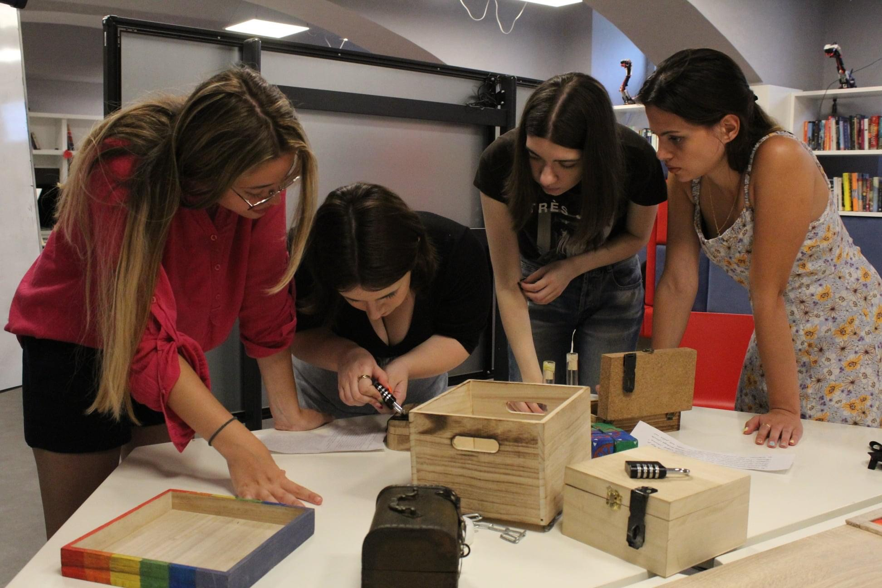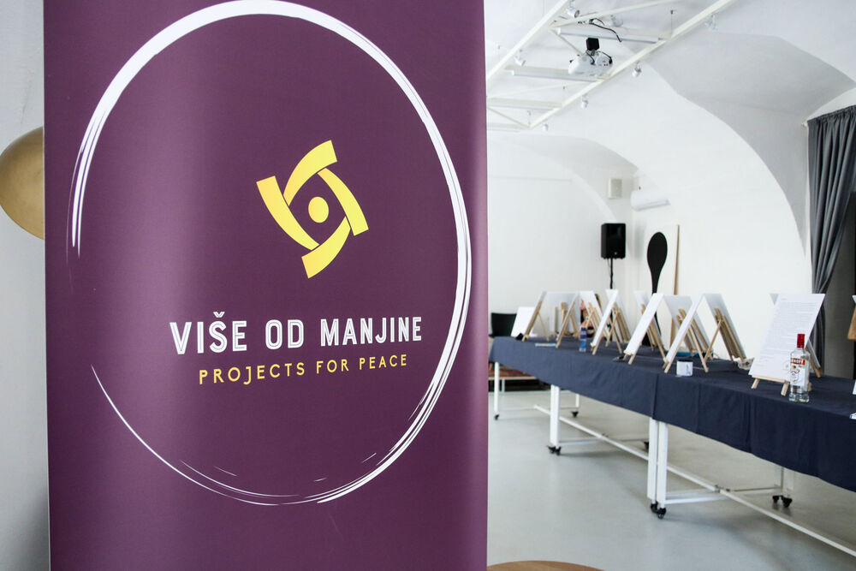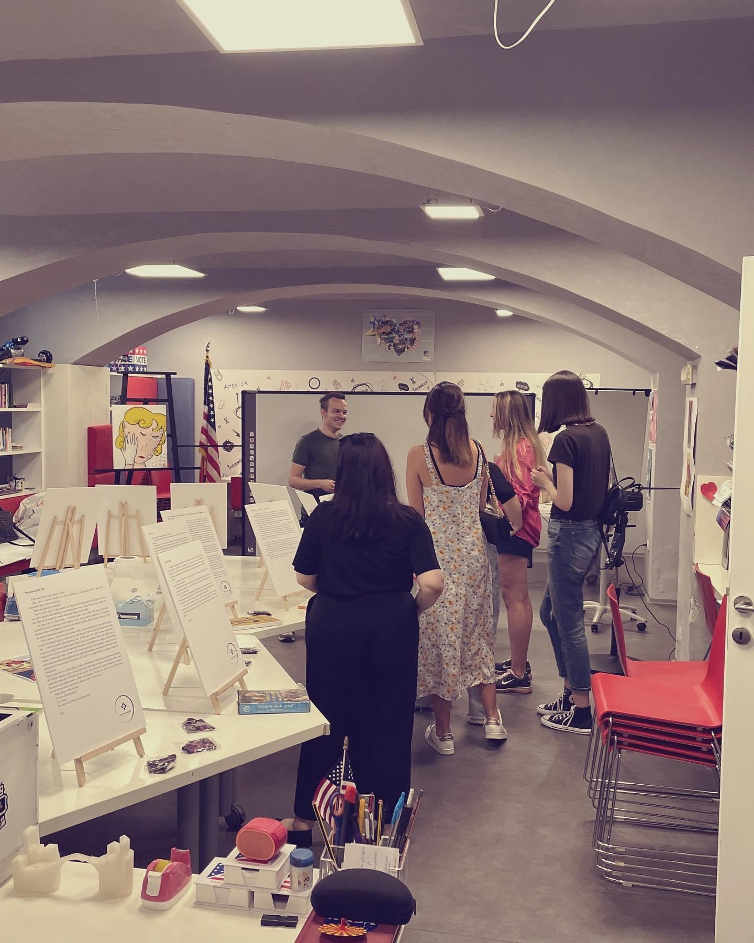

https://www.slobodnaevropa.org/a/30336168.html
https://www.dw.com/hr/teško-je-biti-gej-u-bih/a-39327825

